A

Micro project

On

**“Stone Paper Scissor game**

**using JavaScript (CSS)”**

Submitted By

**Riddhi Rajendra Pawar (21)**

**Guided By**

**Mrs. S.S.Kadam**

Diploma Course in Computer Technology

(As per directives of I Scheme, MSBTE)



Sinhgad Institutes

Sinhgad Technical Education Society’s

**SOU.VENUTAI CHAVAN POLYTECHNIC**

**PUNE - 411041**

**ACADEMIC YEAR 2021-2022**



**Maharashtra State Board of Technical Education**

***Certificate***

This is to certify that **Ms. Riddhi Rajendra Pawar** Roll No. **21** of Semester **V** of Diploma in **Computer Technology** of Institute **Sou. Venutai Chavan Polytechnic (Code: 0040)** has successfully completed the **Micro-Project** in **Client** **Side Scripting (22519)** for the academic year **2021-2022** as prescribed in the curriculum.

Program Code: CM

Course Code: CM/5/I

Place: SVCP, Pune Enrolment No: 1900400216

Date: Exam Seat No:

|  |  |  |
| --- | --- | --- |
| Mrs S.S Kadam | Mrs. A.V. Kurkute | Dr.(Mrs.) M.S. Jadhav |
| **Subject Teacher** | **HOD** | **Principal** |
|  |  |  |

**INDEX**

|  |  |  |
| --- | --- | --- |
| **SR NO** | **CONTENTS** | **PAGE NO** |
| **1** | Aim of the Micro-Project | **1** |
| **2** | Rationale | **3** |
| **3** | Course Outcomes Achieved | **3** |
| **4** | Literature Review | **3** |
| **5** | Actual Methodology Followed | **4** |
| **6** | Actual Resources Used | **4** |
| **7** | Source code | **4** |
| **8** | Output | **13** |
| **9** | Skills Developed | **15** |
| **10** | Applications of Micro Project | **15** |
| **11** | Conclusion | **15** |

**Annexure - I**

**Micro-Project Proposal**

1. **Aim of the Micro-Project:**

“Developing a stone paper scisscor game using Javascript”

1. **Intended Course Outcomes:**

**a)** “Implement Arrays and functions in Javascript”

1. **Proposed methodology:**
2. Study the source code
3. Collect information on how to manage web page.
4. Run/Debug the program.
5. Prepare the final report
6. **Action Plan:**

|  |  |  |  |  |
| --- | --- | --- | --- | --- |
| **Sr. No.** | **Details of Activity** | **Planned**  **Start Date** | **Planned Finish Date** | **Name of responsible Team members** |
| **1** | Identify the requirements of the project. | 17/09/2021 | 01/10/2021 | Riddhi Pawar |
| **2** | Design the structure of the project. | 08/102021 | 22/10/2021 | Riddhi Pawar |
| **3** | Collect information regarding Java code used in the calculator. | 22/10/2021 | 12/11/2021 | Riddhi Pawar |
| **4** | Run the program. | 12/11/2021 | 26/11/2021 | Riddhi Pawar |
| **5** | Check each information correctly. | 26/11/2021 | 10/12/2021 | Riddhi Pawar |
| **6** | Prepare the final report. | 17/12/2021 | 31/12/2021 | Riddhi Pawar |

1. **Resources Required:**

|  |  |  |
| --- | --- | --- |
| **S. No.** | **Resources required** | **Specifications** |
| **1** | Computer system | Intel(R) Pentium CPU, RAM 4 GB |
| **2** | Operating System | Windows 10, 64 Bit Operating System |
| **3** | Software’s | Visual Studio Code |

1. **Team members:**

|  |  |  |
| --- | --- | --- |
| **S. No.** | **Roll. number** | **Name of Student** |
| **1** | 06 | Disha Raskar |
| **2** | 20 | Ninad Pawar |
| **3** | 21 | Riddhi Pawar |

**Annexure-II**

**Micro-Project Report**

1. **Rationale:**

JavaScript is a text-based programming language used both on the client-side and server-side that allows you to make web pages interactive. Where as HTML and CSS are languages that give structure and style to web pages, JavaScript gives web pages interactive elements that engage a user. JavaScript allows you to create highly responsive interfaces that improve the user experience and provide dynamic functionality, without having to wait for the server to react and show another page.

1. **Aim of the Micro-Project:**

“Developing a stone paper scisscor game using Javascript”

1. **Course Outcomes Achieved:**

**b)** “Implement Arrays and functions in Javascript”

1. **Literature Review:**

JavaScript is a scripting or programming language that allows you to implement complex features on web pages every time a web page does more than just sit there and display static information for you to look at displaying timely content updates, interactive maps, animated 2D/3D graphics, scrolling video jukeboxes, etc.

Rock–Paper–Scissors (RPS), a game of cyclic dominance, is not merely a popular children’s game but also a basic model system for studying decision-making in non-cooperative strategic interactions. Aimed at students of physics with no background in game theory, this paper introduces the concepts of Nash equilibrium and evolutionarily stable strategy, and reviews some recent theoretical and empirical efforts on the non-equilibrium properties of the iterated RPS, including collective cycling, conditional response patterns and microscopic mechanisms that facilitate cooperation. We also introduce several dynamical processes to illustrate the applications of RPS as a simplified model of species competition in ecological systems and price cycling in economic markets.

### .

1. **Actual Methodology Followed:**

This Micro-project aims to develop a webpage for calculating loan.

1. Study the source code
2. Collect information on how to manage web page.
3. Run/Debug the program.
4. Prepare the final report.
5. **Actual Resources Used:**

|  |  |  |
| --- | --- | --- |
| **S. No.** | **Resources required** | **Specifications** |
| **1** | Computer system | Intel(R) Pentium CPU, RAM 4 GB |
| **2** | Operating System | Windows 10, 64 Bit Operating System |
| **3** | Software’s | Visual Studio Code |

1. **Source Code:**

**HTML**

* **Index.html**

<html>

<head>

<style>

img.game{

position:absolute;

background-size: cover;

background-repeat: no-repeat;

height: 100%;

width: 100%;

left: 0px;

top: 0px;

z-index: -1;

}

h1{

color: rgb(9, 6, 112);

font-size: 65px;

padding-top: 35px;

padding-bottom: 10px;

font-family:'Times New Roman', Times, serif;

text-shadow: 5px 5px cornsilk;

}

.but{

width:180px;

height: 60px;

color: rgb(99, 17, 17);

border-radius: 15px;

font-family:'Times New Roman', Times, serif;

font-size: 25px;

cursor: pointer;

white-space: nowrap;

transition: 0.2s all linear ;

outline: none;

border: 1px solid;

padding: 10px;

box-shadow: 10px 15px rgb(160, 160, 160);

transition-duration: 0.4s;

}

.but:hover{

background-color: rgb(235, 111, 53);

}

</style>

<title>Stone Paper Scissor Game</title>

</head>

<body>

<center><h1>WELCOME TO THE GAME</h1></center>

<img class="game" src="game1.JPG">

<br>

<center><a href="Game.html"><input type="button" value="Play Now" class="but"></center></a>

</body>

</html>

* **Game.html**

<html>

<link rel="stylesheet" href="Game.css">

<head>

<title>Game</title>

</head>

<body>

<div class="container">

<div class="message">CHOOSE AN OPTION</div>

<div class="images">

<div class="computer">

<!--

Download Images from this link-

https://bit.ly/31Prgax

-->

<img src="stoneComputer.png">

</div>

<div class="player">

<img src="stonePlayer.png" />

</div>

</div>

<div class="points">

COMPUTER <span class="computerPoints">0</span> /

<span class="playerPoints">0</span> PLAYER

</div>

<div class="options">

<button type="button">STONE</button>

<button type="button">PAPER</button>

<button type="button">SCISSORS</button>

</div>

</div>

</body>

</html>

* **Game.css**

body {

background: #2d2a3d;

color: #fff;

font-family: "Poppins";

}

.message {

margin: 5em 0 2em;

text-align: center;

}

.images {

display: flex;

justify-content: space-around;

align-items: center;

text-align: center;

height: 200px;

}

.computer img,

.player img {

width: 75%;

}

.shakeComputer {

animation: shakeComputer 0.8s linear;

}

.shakePlayer {

animation: shakePlayer 0.8s linear;

}

.points {

margin: 2em 0;

text-align: center;

}

.computerPoints {

margin-left: 3em;

}

.playerPoints {

margin-right: 3em;

}

.options {

margin-top: 5em;

display: flex;

justify-content: space-around;

}

.options button {

background: none;

color: #fff;

font-family: "Poppins";

border: 1px solid #fff;

padding: 1em 2em;

border-radius: 7px;

width: 150px;

white-space: nowrap;

cursor: pointer;

outline: none;

transition: 0.2s all linear;

}

.options button:hover {

background-color: darkcyan;

border: 1px solid darkcyan;

}

@keyframes shakeComputer {

0% {

transform: rotate(-30deg);

}

25% {

transform: rotate(30deg);

}

50% {

transform: rotate(-30deg);

}

75% {

transform: rotate(30deg);

}

100% {

transform: rotate(0deg);

}

}

@keyframes shakePlayer {

0% {

transform: rotate(30deg);

}

25% {

transform: rotate(-30deg);

}

50% {

transform: rotate(30deg);

}

75% {

transform: rotate(-30deg);

}

100% {

transform: rotate(0deg);

}

}

* **Game.js**

const computer = document.querySelector(".computer img");

const player = document.querySelector(".player img");

const computerPoints = document.querySelector(".computerPoints");

const playerPoints = document.querySelector(".playerPoints");

const options = document.querySelectorAll(".options button");

options.forEach((option) => {

option.addEventListener("click", () => {

computer.classList.add("shakeComputer");

player.classList.add("shakePlayer");

setTimeout(() => {

computer.classList.remove("shakeComputer");

player.classList.remove("shakePlayer");

player.src = "./" + option.innerHTML + "Player.png";

const choice = ["STONE", "PAPER", "SCISSORS"];

let arrayNo = Math.floor(Math.random() * 3);

let computerChoice = choice[arrayNo];

computer.src = "./" + computerChoice + "Computer.png";

let cPoints = parseInt(computerPoints.innerHTML);

let pPoints = parseInt(playerPoints.innerHTML);

if (option.innerHTML === "STONE") {

if (computerChoice === "PAPER")

computerPoints.innerHTML = cPoints + 1;

else if (computerChoice === "SCISSORS")

playerPoints.innerHTML = pPoints + 1;

} else if (option.innerHTML === "PAPER") {

if (computerChoice === "SCISSORS")

computerPoints.innerHTML = cPoints + 1;

else if (computerChoice === "STONE")

playerPoints.innerHTML = pPoints + 1;

} else {

if (computerChoice === "STONE")

computerPoints.innerHTML = cPoints + 1;

else if (computerChoice === "PAPER")

playerPoints.innerHTML = pPoints + 1;

}

}, 900);

});

});

1. **Output:**

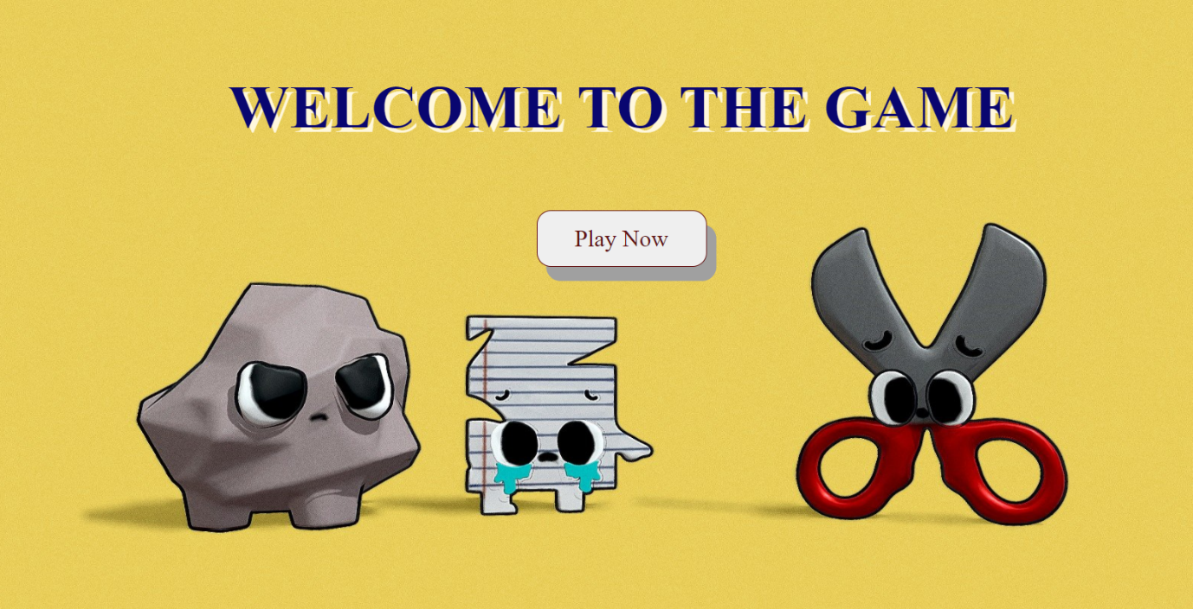

**Fig 8.0.1**

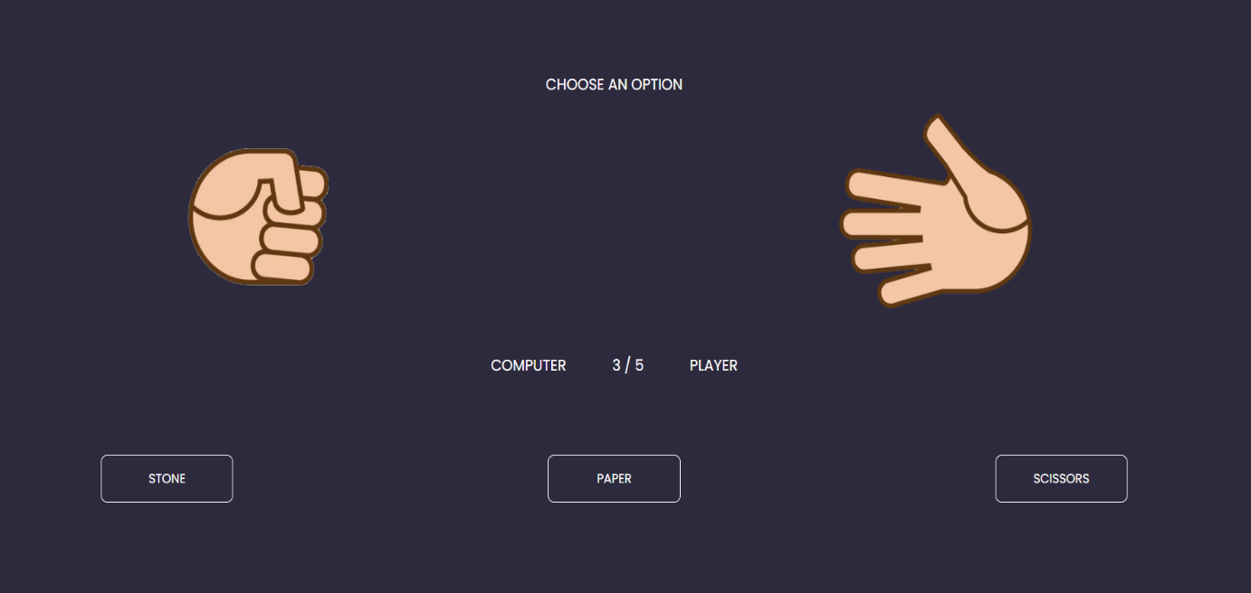

**Fig 8.0.2**

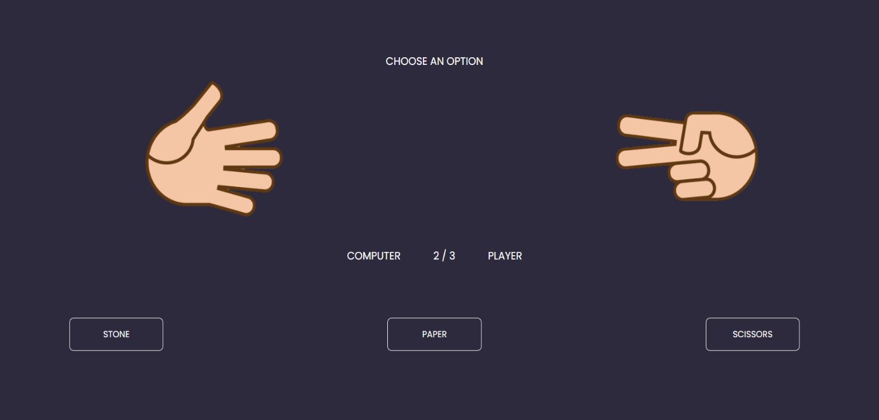

**Fig 8.0.3**

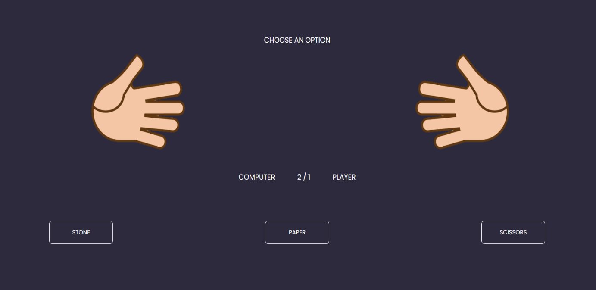

**Fig 8.0.4**

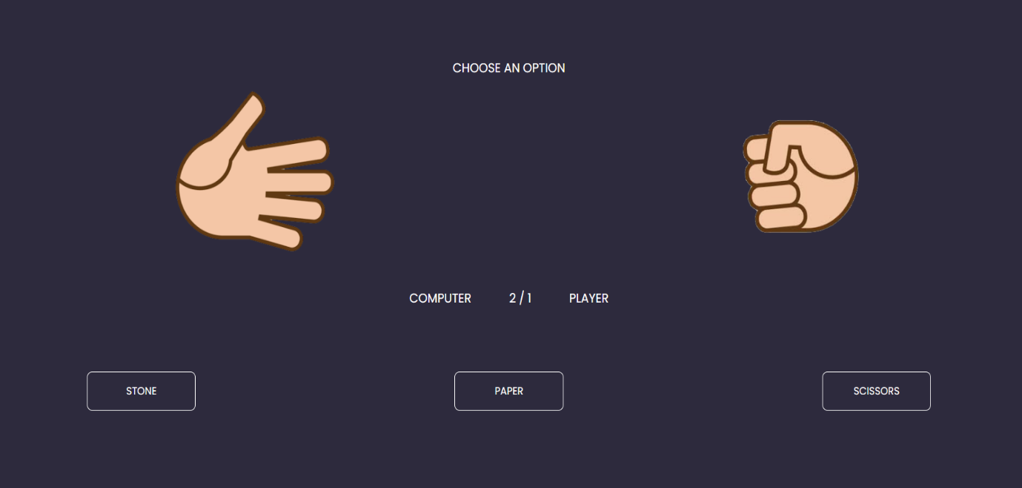

**Fig 8.0.5**

1. **Skills Developed:**

During the course of this micro-project, we learned how to design a web page using Client Side Scripting.

a) Created a web page(html & Javascript).

b) Usage of different functions while creating a web page.

1. **Applications of this Micro-project:**

This micro-project finds its application in:

a) Studied Arrays and Functions in CSS.

b) For learning their use in different programs.

1. **Area of future Improvement:**

In the future, we can add functions like how to calculate fat and muscle index separately.

1. **Conclusion:**

We learned about developing a webpage using CSS(JavaScript).